**SUCCESS INTEGRATED NURSERY SCHOOL**

**Internal End of First Term Examinations 2020**

**Literacy 5-6 years**

Name _____________________________Stream____________

1. **X the body parts.**

a) cat ear rat

b) nose shorts boy

c) tongue food stick

2. **Match things used to clean the environment to words.**

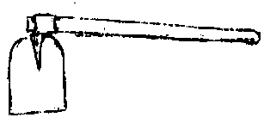 wheel barrow

[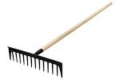](https://www.google.com/url?q=http://www.fiskars.eu/Gardening-Yard-Care/Discontinued/135521-Contractor-s-Rake&sa=U&ei=6iTKU4-0M8jK0QWq3oCwDw&ved=0CCIQ9QEwBg&usg=AFQjCNEis8PQuLRmA6aqg6xn6HZhcjv0_Q)

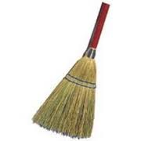 broom

[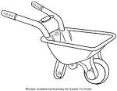](https://www.google.com/url?q=http://quoteko.com/wheelbarrow-coloring-page.html&sa=U&ei=9a0SVK2oGMuWapLigYAJ&ved=0CCgQ9QEwCDgo&usg=AFQjCNGKOBUm5CDtbWTmQtXwGNLwkSar-A) hoe

rake

3. **Read and draw things used to clean our body.**

|  |  |  |  |
| --- | --- | --- | --- |
| toothbrush | toothpaste | water | razorblade |
|  |  |  |  |

4. **Fill in the missing letters.**

ey___ m__uth n__se ea__s

5. **Complete the sentences.**

I have ___________ senses.

Mummy has ______________legs

[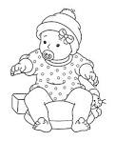](http://www.google.com/imgres?imgurl=http://www.eloradollhouse.com/Realtime/Dolls/photos_x/31311162659.jpg&imgrefurl=http://www.eloradollhouse.com/Realtime/Dolls/Baby-Doll-Coloring-Page.php&usg=__a2myzQ72IoRuEgyzBQrz66YUdcc=&h=960&w=789&sz=302&hl=en&start=1&zoom=1&tbnid=N2VH9X_GRW1LOM:&tbnh=148&tbnw=122&ei=Gj-3Uez3M8eKhQfgxYGoCA&prev=/search?q=dolls&sa=X&hl=en&sout=1&biw=985&bih=443&site=imghp&tbs=itp:lineart&tbm=isch&itbs=1&sa=X&ved=0CC4QrQMwAA)6. **Match people at home to words.**

mother

[](https://www.google.com/url?q=http://nickilemas.wordpress.com/category/uncategorized/&sa=U&ei=ejg5U93-CMnXtQadloHoBw&ved=0CDgQ9QEwBDgU&usg=AFQjCNGaY4i8OToNsUJAB7qd95qe3nHSAg)

baby

[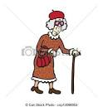](https://www.google.com/url?q=http://www.canstockphoto.com/old-woman-13096953.html&sa=U&ei=mcgzVKetO9Hfavf8gpAG&ved=0CDIQ9QEwDQ&usg=AFQjCNHx0B5Qn07Bp0TTSbN5u4a7XOH_sw)

grandfather

[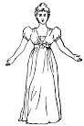](http://www.google.com/imgres?imgurl=http://etc.usf.edu/clipart/3800/3854/woman_1_md.gif&imgrefurl=http://etc.usf.edu/clipart/3800/3854/woman_1.htm&usg=__r5Ar18cdpJDctxKEHeZQVjbYcZ0=&h=640&w=430&sz=26&hl=en&start=129&zoom=1&tbnid=tJ9j4fStsEWSlM:&tbnh=137&tbnw=92&ei=Tjq3UcnnBtS7hAfN_YGgDg&prev=/search?q=woman&start=120&sa=N&hl=en&sout=1&biw=985&bih=443&site=imghp&tbs=itp:clipart&tbm=isch&itbs=1&sa=X&ved=0CD4QrQMwCDh4)

sister

[](http://www.google.com/imgres?imgurl=http://previews.123rf.com/images/dukepope/dukepope1201/dukepope120100004/12044178-Old-Man-Stock-Vector-grandfather-cartoon-people.jpg&imgrefurl=http://www.123rf.com/clipart-vector/pensioner.html&h=1300&w=1300&tbnid=35d6wESyg-FjBM:&zoom=1&docid=OiW6wkNBxUYH4M&hl=en&ei=4T1fVd_cD8-P7Ab1_oCABQ&tbm=isch&ved=0CGYQMyhiMGI4ZA)

grandmother

7. **Underline things used to clean the environment.**

trashcan sponge soap

rake vaseline eyes

towel hoe baby

sister broom brother

8. **Read and draw the body parts.**

head legs eyes

[](https://www.google.com/url?q=http://etc.usf.edu/clipart/19100/19127/soap_19127.htm&sa=U&ei=nl3TU-inCcSX1AWxt4DQCA&ved=0CBwQ9QEwAg&usg=AFQjCNFWinB6NFXrHlJV6JaB3KMY27lEKg)9. **Match pictures to words.**

toothpaste

[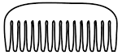](http://www.google.com/url?url=http://nearpictures.com/pages/h/hair-brush-and-comb-clip-art/&rct=j&frm=1&q=&esrc=s&sa=U&ved=0CDoQwW4wETgUahUKEwiU_5yd-6PIAhVF1BoKHWjxBRM&usg=AFQjCNHeQxlI8mEPzysZyXClB9cJ9uIobg)

vaseline

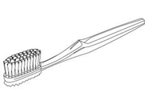

comb

soap

[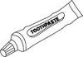](http://www.google.com/imgres?imgurl=http://classroomclipart.com/images/gallery/Clipart/Black_and_White_Clipart/Home/TN_09-10_S_05_27BBW.jpg&imgrefurl=http://classroomclipart.com/clipart-search/all-phrase/toothpaste/&usg=__TLWSt7Rj8FrfXQrFzP4gS5By8k4=&h=120&w=175&sz=25&hl=en&start=17&zoom=1&tbnid=kptFMYTHcM4ioM:&tbnh=69&tbnw=100&ei=cKheUuCnJrGS0QW2g4BI&itbs=1&sa=X&ved=0CE4QrQMwEA)

toothbrush

10. **Match body parts to their uses.**

eyes smelling

legs hearing

nose tasting

ears seeing

tongue walking

11. **Draw the food we eat.**

|  |  |  |
| --- | --- | --- |
| eggs | fish | mango |
|  |  |  |

[](https://www.google.com/url?q=http://www.modernghana.com/news/374556/1/praad-and-others-neglected-and-relegated-to-the-du.html&sa=U&ei=XV85U7-NH8aktAbK7IAo&ved=0CFYQ9QEwEw&usg=AFQjCNE4iCmSX6qoPN_uaWm0SxZ74bPwug)12. **Z the correct word for the picture.**

dustbin bucket

[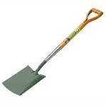](https://www.google.com/url?q=http://www.gardenstreet.co.uk/garden-tools-equipment-c4/garden-hand-tools-c47/spades-c58/bulldog-premier-treaded-digging-spade-p201&sa=U&ei=bcgbVN-oFcT5yQO84IAI&ved=0CBoQ9QEwAQ&usg=AFQjCNETOW-CLbyicdkZbuTYmSeFStbFlA)

broom spade

[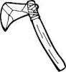](http://www.google.com/url?url=http://www.fotosearch.com/CSP994/k15568886/&rct=j&frm=1&q=&esrc=s&sa=U&ved=0CDgQwW4wEDgUahUKEwjRrJi996PIAhXMChoKHQHvAxk&usg=AFQjCNH993CtOVGfwlrBPAQGhTnStAiiAw)

axe panga

[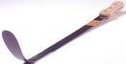](http://www.google.com/imgres?imgurl=http://www.chillingtontoolsonline.co.uk/images/products/large/Grass%20Slasher%202%20001.jpg&imgrefurl=http://www.chillingtontoolsonline.co.uk/grass-slasherweeder-p13&usg=__kt_iu2_7XnBbm0DGE3m3uF8SQtE=&h=258&w=500&sz=8&hl=en&start=18&zoom=1&tbnid=unmn2BcMUy1YgM:&tbnh=67&tbnw=130&ei=DXWEUtGLDonJswak9oCYAw&itbs=1&sa=X&ved=0CFAQrQMwEQ)

knife slasher

[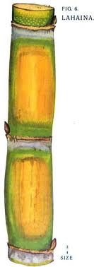](http://www.google.co.ug/imgres?q=sugarcane&hl=en&biw=1366&bih=535&tbs=itp:clipart&tbm=isch&tbnid=_LdxXrgSWP5sBM:&imgrefurl=http://jasonrriley.wordpress.com/tag/sartre/&docid=OnMMRWP0Gp1OXM&imgurl=http://jasonrriley.files.wordpress.com/2010/09/sugar-cane.jpg&w=250&h=707&ei=oLGXULvSFcnvsgaGuoGwDw&zoom=1&iact=hc&vpx=442&vpy=2&dur=1000&hovh=378&hovw=133&tx=74&ty=125&sig=114549910144603029910&page=3&tbnh=160&tbnw=57&start=39&ndsp=20&ved=1t:429,r:15,s:39,i:309)13. **Tick the correct name of the fruit.**

stick sugarcane

[](http://www.google.com/url?url=http://www.publicdomainpictures.net/view-image.php?image=77527&large=1&rct=j&frm=1&q=&esrc=s&sa=U&ved=0CC4QwW4wC2oVChMImpORxqP0yAIVyNMUCh0NbAL5&usg=AFQjCNEmEI92d1LZB94rIFggJYTsqc1GXg)

apple stone

[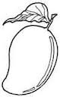](http://www.google.co.ug/imgres?q=mangoes&start=79&hl=en&sa=X&biw=1366&bih=535&addh=36&tbs=itp:lineart&tbm=isch&tbnid=zlU-wNqVQPdr9M:&imgrefurl=http://www.imgsearch365.com/mango-colouring-page.html&docid=DZ0D6Jfn1oxOHM&imgurl=http://ts1.mm.bing.net/th?id=H.4549930223403168&pid=15.1&w=99&h=160&ei=irCXUMOABcbXsga7mYC4BA&zoom=1&iact=hc&vpx=465&vpy=211&dur=953&hovh=128&hovw=79&tx=93&ty=65&sig=114549910144603029910&page=5&tbnh=128&tbnw=79&ndsp=22&ved=1t:429,r:10,s:79,i:37)

ball mango

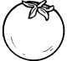 orange pineapple

14. **Fill in the missing letters.**

m__ther sist__r grandm__ther

f__ther ba__y broth__r